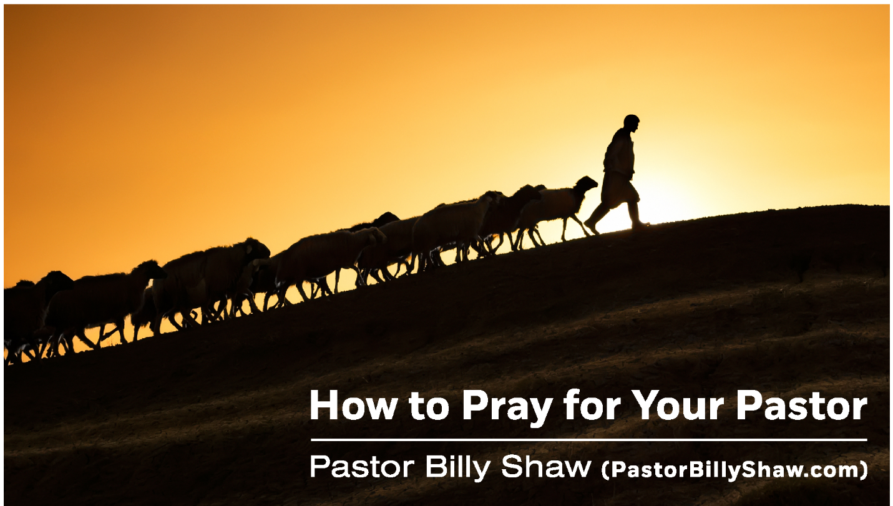

How to Pray for Your Pastor
Participant Guide
Led by Pastor Billy Shaw
Attain Consulting, Inc.
Grace Baptist Church of Fayetteville, NC

Introduction: Since prayer is talking to God, praying for your pastor is simply ________________________________________ about your pastor.

- Pray for Your Pastor’s M__________________ of the W__________.

2 Thessalonians 3:1 (NKJV), “Finally, brethren, pray for us that the Word of the Lord may run swiftly and be glorified just as it is with you.”

- That the Word would Run S______________

- That the Word would Be G_______________

Ephesians 6:19 (NKJV), “That utterance may be given to me that I may open my mouth boldly to make known the mystery of the Gospel.”

- That the Pastor would have B__________________

- That the Pastor would have C__________________

- Pray for Your Pastor to Be D__________________________ from M___________________ U_________________.

2 Thessalonians 2:3-6, “and that we may be delivered from unreasonable and wicked men, for not all have faith.”

Romans 15:31, “That I may be delivered from those in Judea who do not believe.”

- Pray for Your Pastor to Be R____________________ through Personal Relationships.

Romans 15:32-33, “I beg you, brethren, through the Lord Jesus Christ and through the love of the Spirit that you strive together with me in prayers to God for me….that I may come to you with joy by the will of God and may be refreshed together with you.”

See also Philemon 22

- Pray for Your Pastor’s F_________________.

1 Timothy 3 (selected verses), “husband of one wife…one who rules his own house well, having his children in submission with all reverence. For if a man does not know how to rule his own house, how will he take care of the church of God?

NOTE: Register today for the DEEP DIVE Webinar in the Doctrine of Christ! Vote for your favorite small group leader!

- Pray for Your Pastor’s P____________________ Health.

Philippians 2:25-30

Philippians 1:22, “But if I live on in the flesh, this will mean fruit from my labor; yet what I shall choose I cannot tell. For I am hard-pressed between the two, having a desire to depart and be with Christ, which is far better. Nevertheless to remain in the flesh is more needful for you.”

Please provide feedback on the Webinar and download your bonuses at www.pastorbillyshaw.com/OnDemand
Write to me any time pastorbillyshaw@gmail.com.

